Navigate to URL:

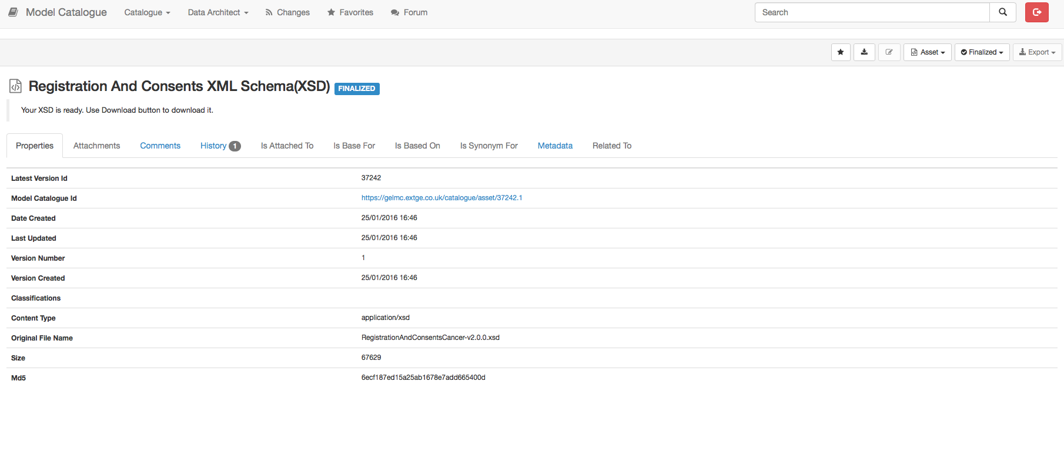

Registration and Consents:

https://gelmc.extge.co.uk/#/catalogue/asset/37242

Diagnoses:

https://gelmc.extge.co.uk/#/catalogue/asset/37247

Disease Information Updates:

https://gelmc.extge.co.uk/#/catalogue/asset/37243

Referrals:

https://gelmc.extge.co.uk/#/catalogue/asset/37244

Risk Factor Assessments:

https://gelmc.extge.co.uk/#/catalogue/asset/37245

Investigations:

https://gelmc.extge.co.uk/#/catalogue/asset/37245

Consent Updates:

https://gelmc.extge.co.uk/#/catalogue/asset/37245

Cancer Care Plans:

https://gelmc.extge.co.uk/#/catalogue/asset/37249

Interventions:

https://gelmc.extge.co.uk/#/catalogue/asset/37249

Withdrawals:

https://gelmc.extge.co.uk/#/catalogue/asset/37249

Deaths:

https://gelmc.extge.co.uk/#/catalogue/asset/37252

Click Asset Menu:

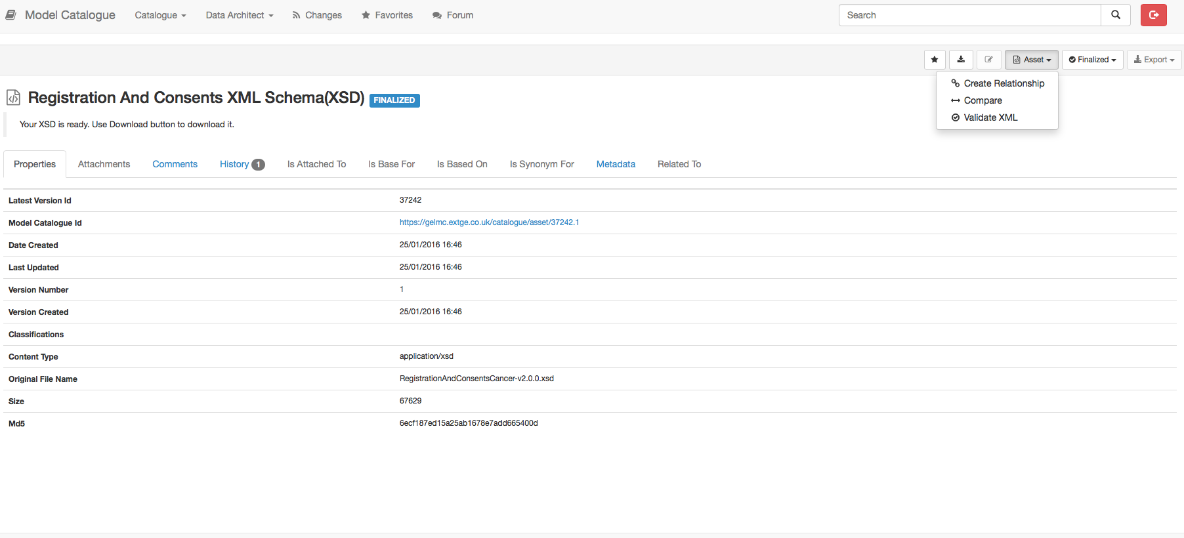

Click Validate XML:

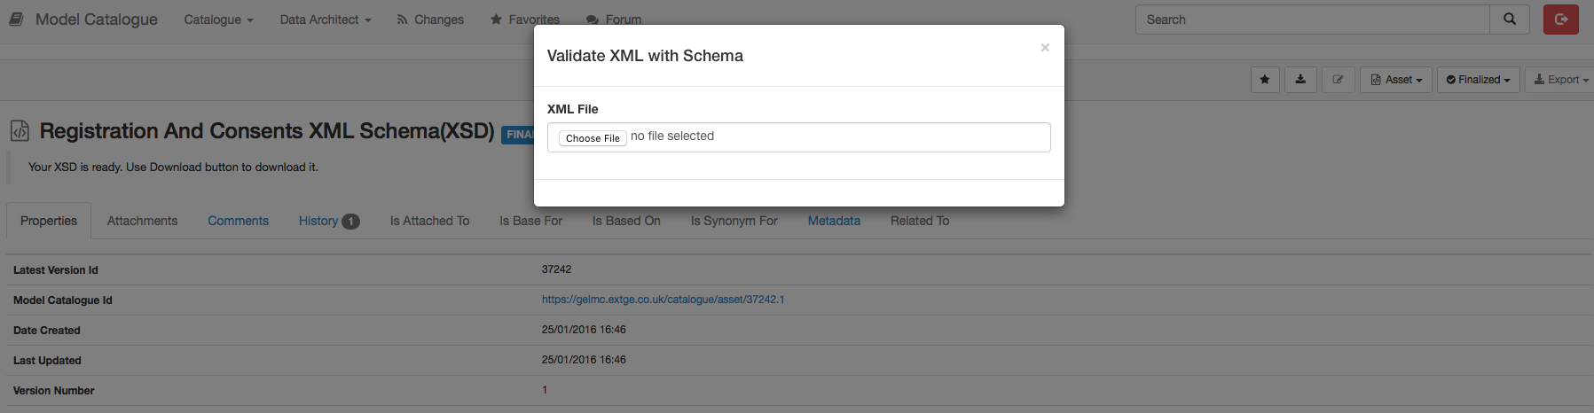

Select XML File to Validate:

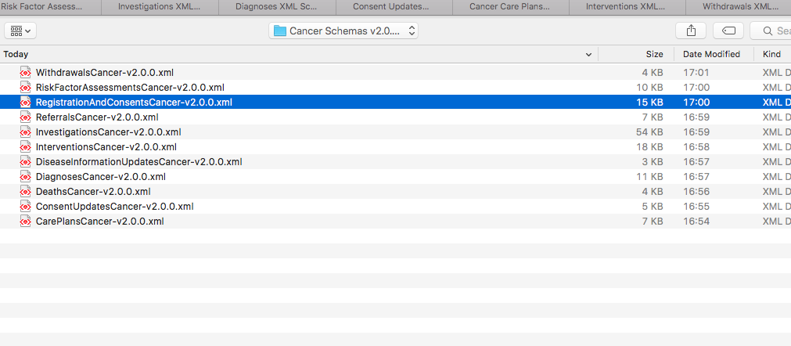

Result should be displayed

